REVERSE CURRENT DETECTION SYSTEMS

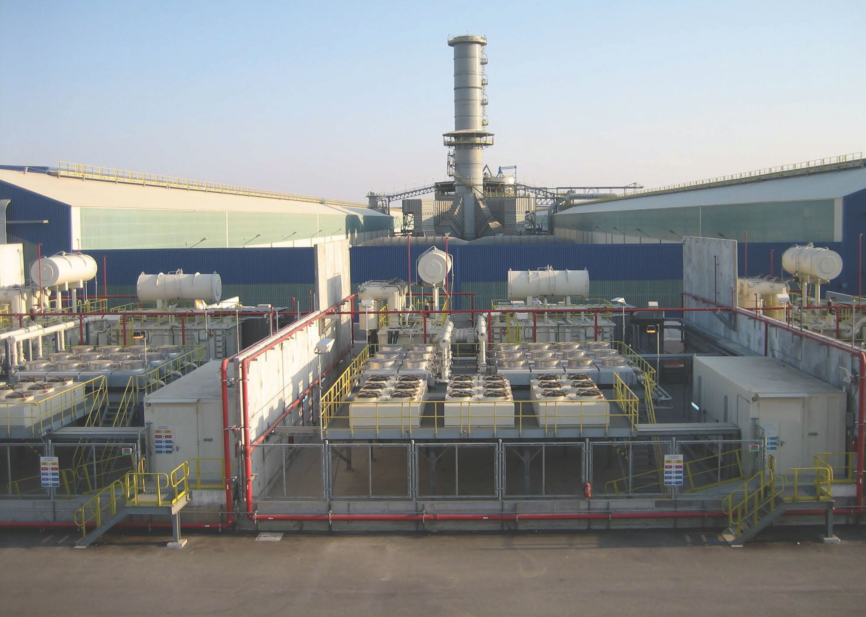

To provide the high DC current required by intensive electro-chemical processes such as aluminium smelting, multiple high-power rectifiers are typically connected in parallel so that together, they can provide very high current.

Today, this approach is providing processes such as aluminium smelting with over 500kA at 2kV in a single bus bar.

However, if an internal short circuit occurs in one of the rectifiers that is not halted/broken by internal fuses or other technique, not only can all the current from the fault rectifier flow through the short circuit, but current from all parallel connected rectifiers may also flow through the short circuit.

Such an extreme short circuit current is catastrophic. It can easily destroy the entire rectifier and damage or destroy the rectifier transformer. It can be explosive to the point of damaging other equipment nearby and cause injury or death to workers in the area.

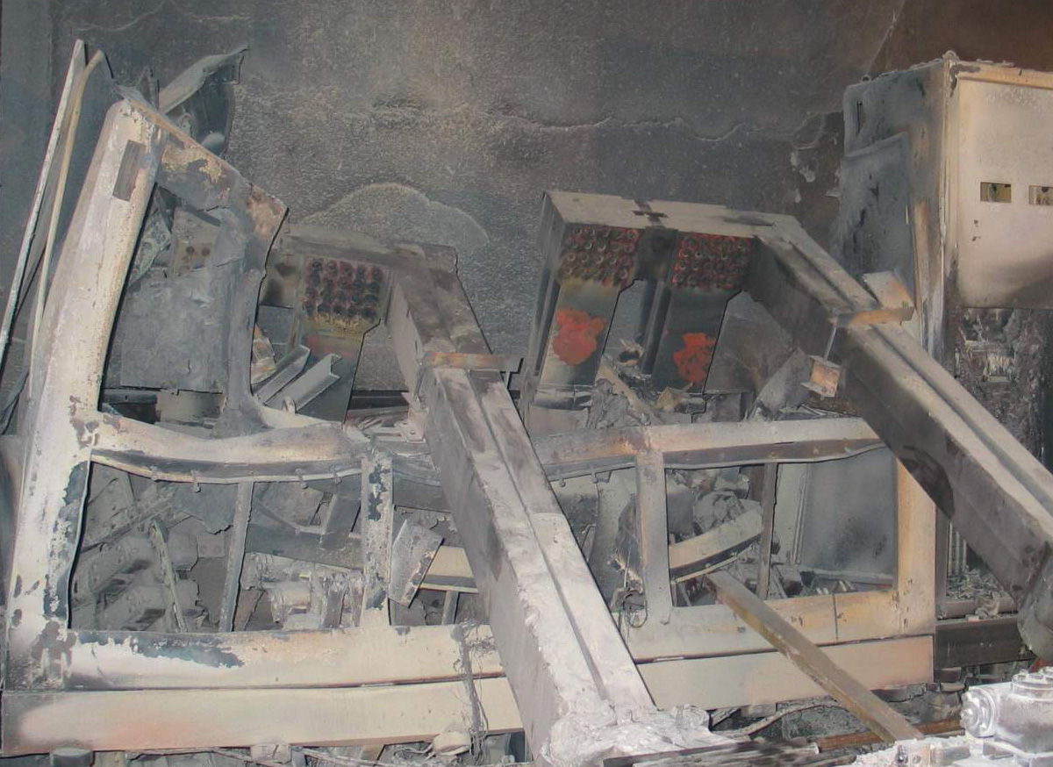

Such an event will also bring down the process line for some period of time. Depending on the electrical and process infrastructure, and the total damage. Even when restarted, the surviving infrastructure may only allow the process to operate at reduced capacity.

Rectifier over-current detection, typically implemented on the primary side of the rectifier transformer, is not effective for reverse-current protection. Typically, over-current detection is used to trip a single rectifier off-line. This is not effective for reverse-current protection since the other, parallel connected rectifiers will continue to ‘feed’ the short circuit. And, because over-current detection is on the primary side of the rectifier transformer, the transformer ratio and inductance reduce and slow the ability to detect a problem after the transformer.

For this reason, most electro-chemical processes supplied by parallel connected rectifiers utilize some form of reverse current detection system “RCDS”.

RCDS alarms if reverse current is detected on the rectifier DC output bus bars. This alarm is used to immediately trip the entire electrical supply to the process off-line to halt the short-circuit current as quickly as possible. It should be noted that even with immediate detection and trip, there still may be some additional damage due to ‘current after trip’ fed by power transformer inductance and the battery effect of most electro-chemical processes. However, the total damage is significantly less that an uncontrolled reverse current event.

To be effective the RCDS must alarm immediately to trip the electrical supply off line as quickly as possible to minimize damage. However, depending on what RCDS system is used and how it is configured, there are varying risks of false alarm. False alarms can result in lost production and unnecessary ‘event’ investigations.

In any case, the benefit of minimizing the damage and loss caused by a real reverse current event is always significantly greater than the cost and nuisance of any false alarm.

The need for RCDS is well understood and confirmed. Even so, there has always been room for improvement regarding ways to reduce the chance of false alarms as close to zero as possible. This Technical Bulletin introduces a newly cost-effective approach to realize a Redundant Reverse Current Detection System which both improves dependability and reduces the chance of false alarms.

Most customers prefer to have RCDS alarms ‘direct-wired’ to the protection system to eliminate any possible issues with PLCs, digital communications and multiplexing. To illustrate how a simple configuration is realized, please consider the following diagram representing 2 high-power rectifiers, with each rectifier having dual outputs.

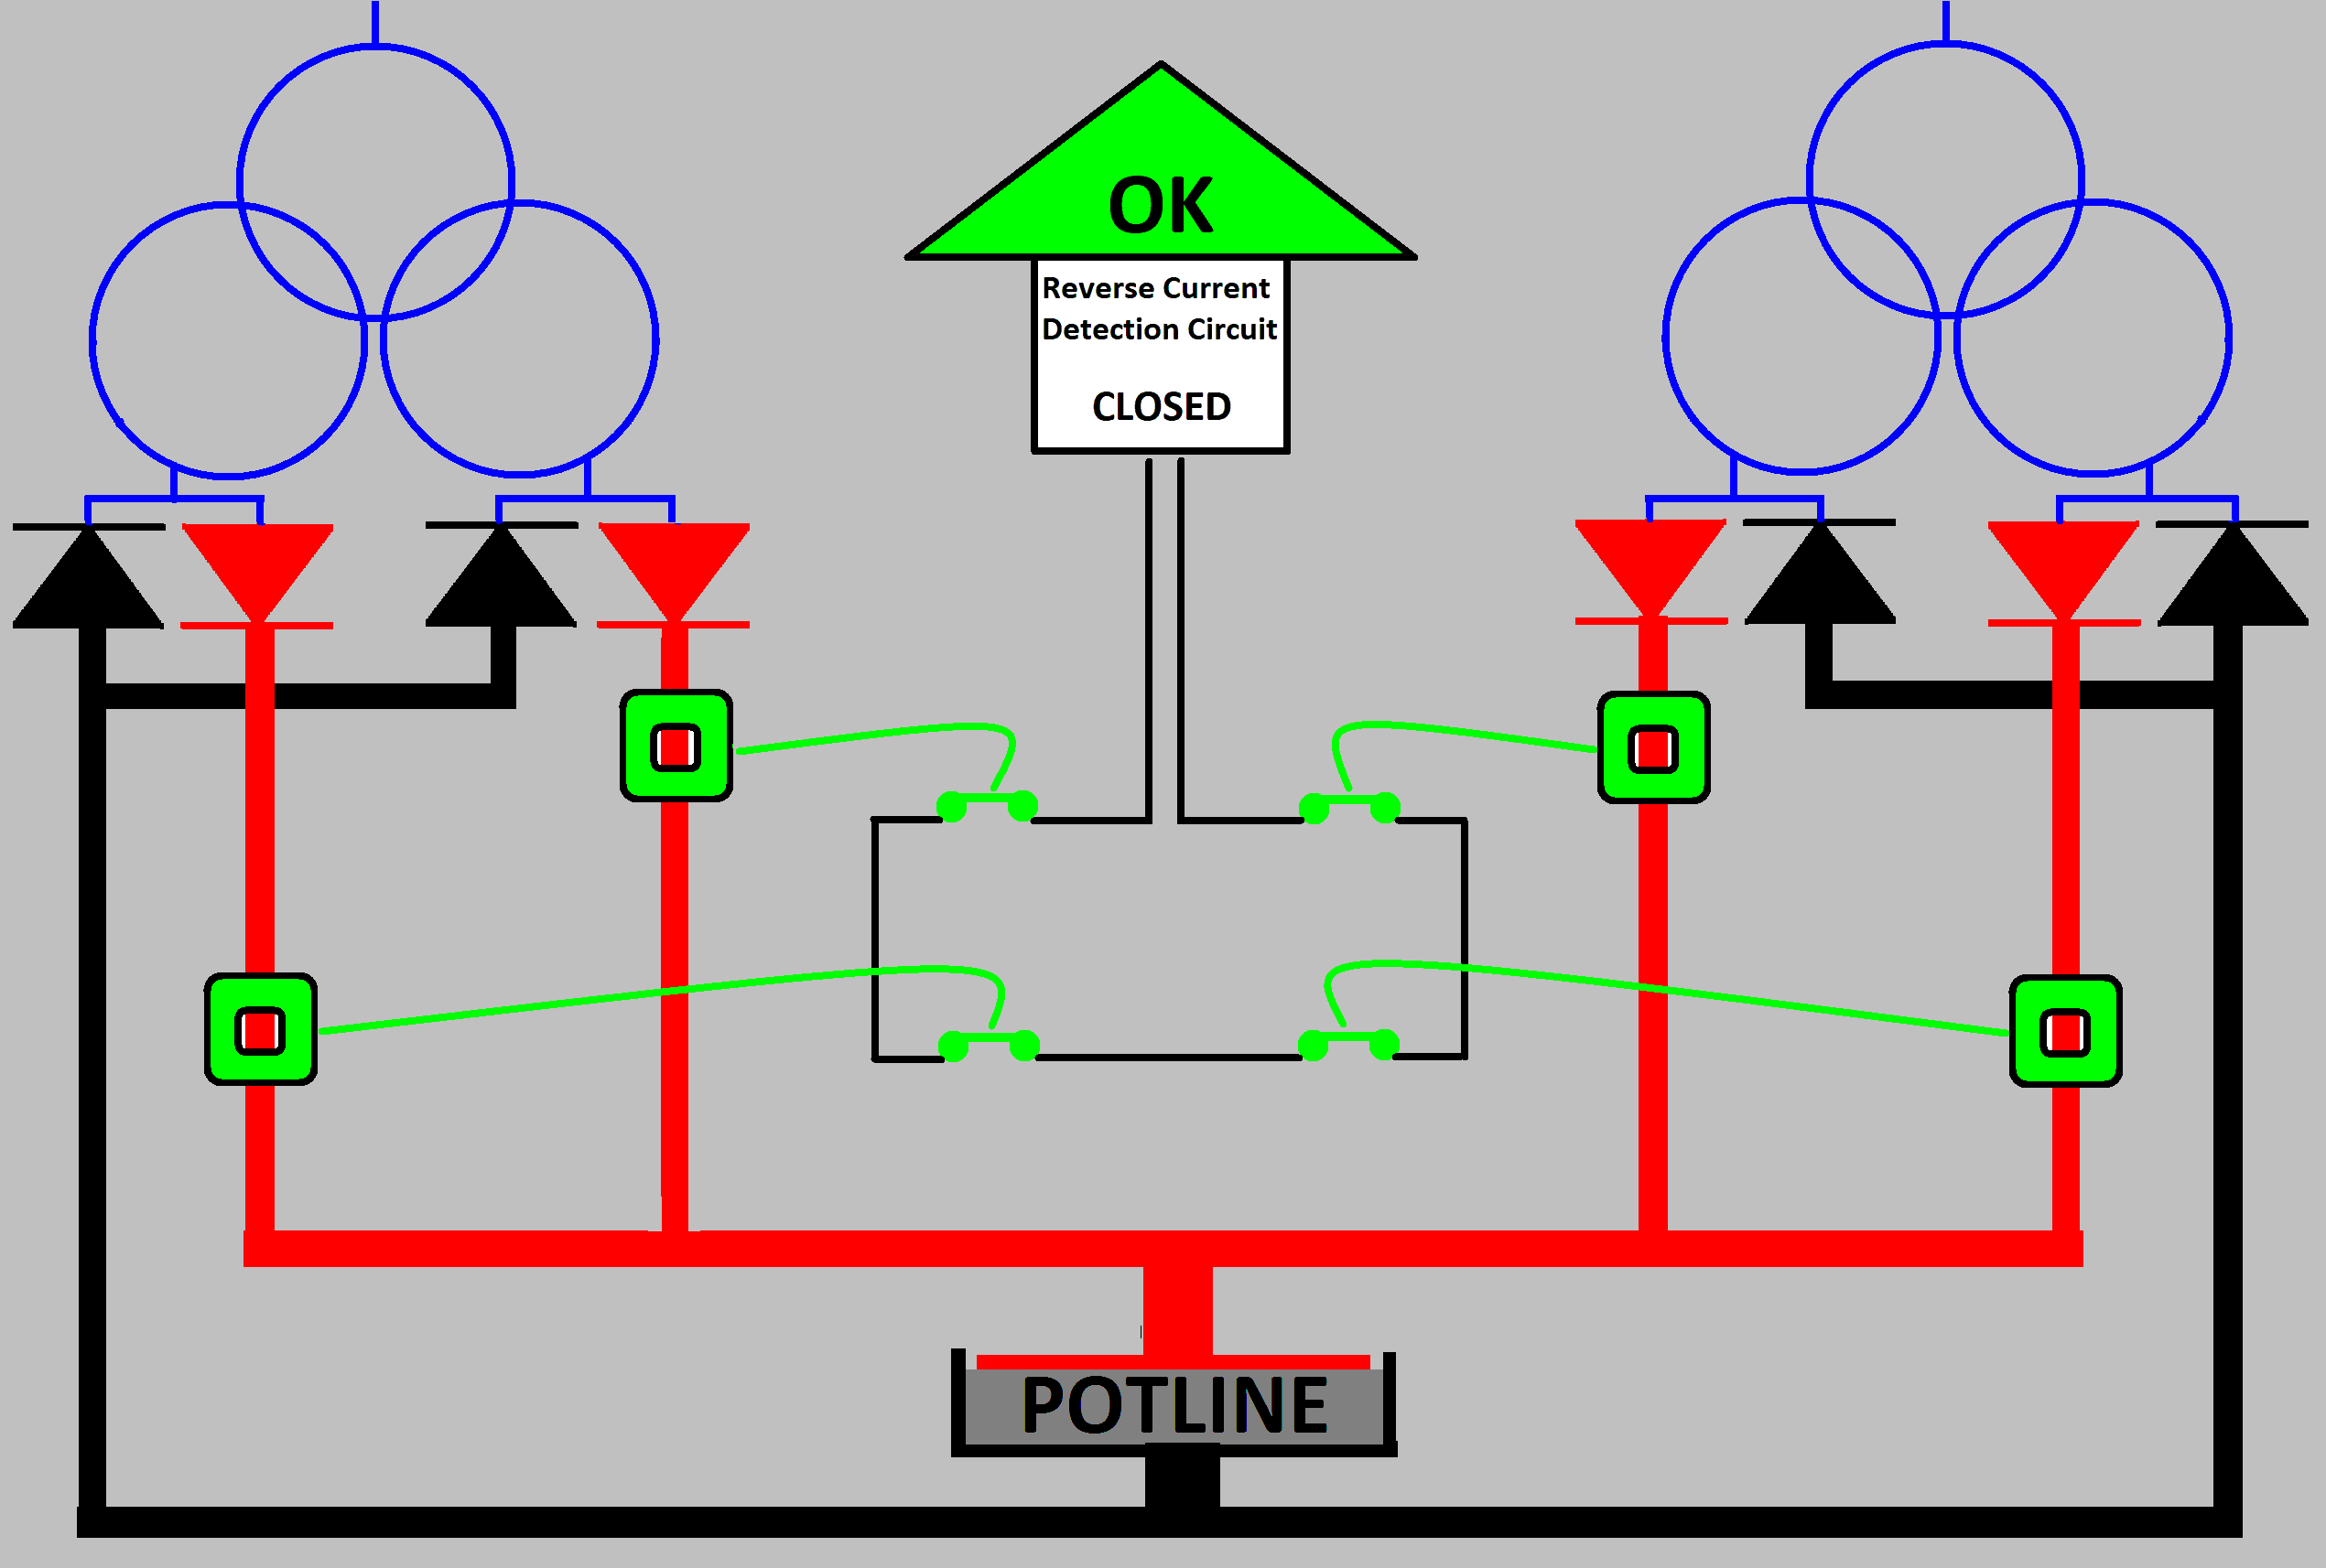

Traditional RCDS configurations

This basic configuration places 1 LKAT () on each of the positive output bus bars. Each LKAT controls a relay / dry contact is configured to be ‘closed’ () in normal operation when no reverse current is present. All individual dry contacts are wired together in ‘series’. This creates a ‘Reverse Current Detection Circuit’ that is ‘closed’ during normal operating conditions.

The following diagram shows RCDS function when a short circuit occurs in one of the rectifiers (shown as yellow).

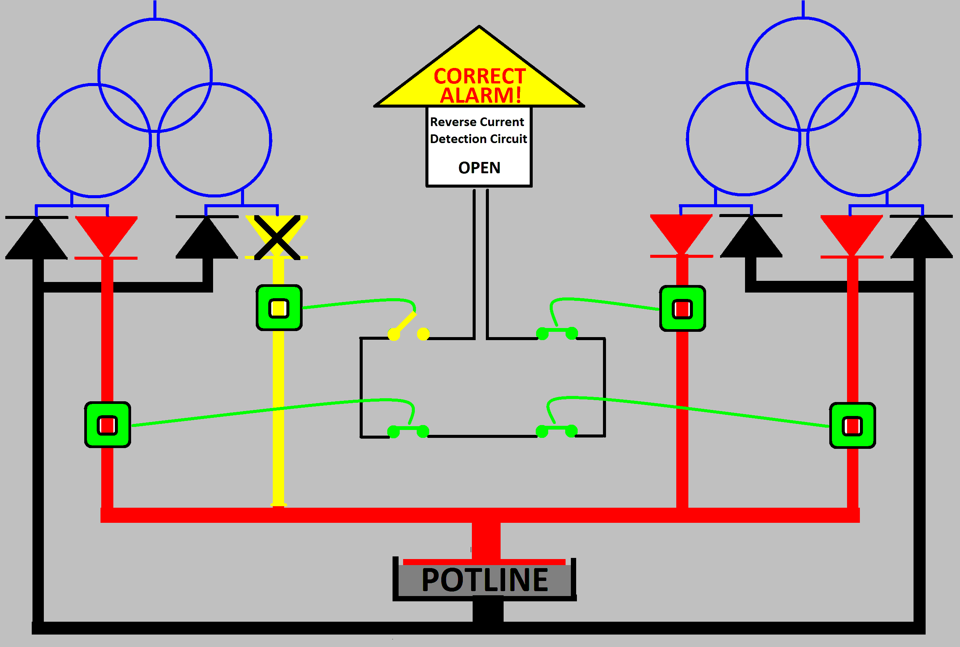

The LKAT will detect the reverse current in the yellow bus bar (reverse current coming from the other parallel rectifiers) and ‘open’ its dry contact. Because all Reverse Current Detection Circuit contacts are wired in series, the overall circuit will ‘open’ signaling a reverse current event. This is used to trip all rectifiers off line to minimize damage.
However there are conditions that may cause the Reverse Current Detection Circuit to incorrectly signal reverse current.

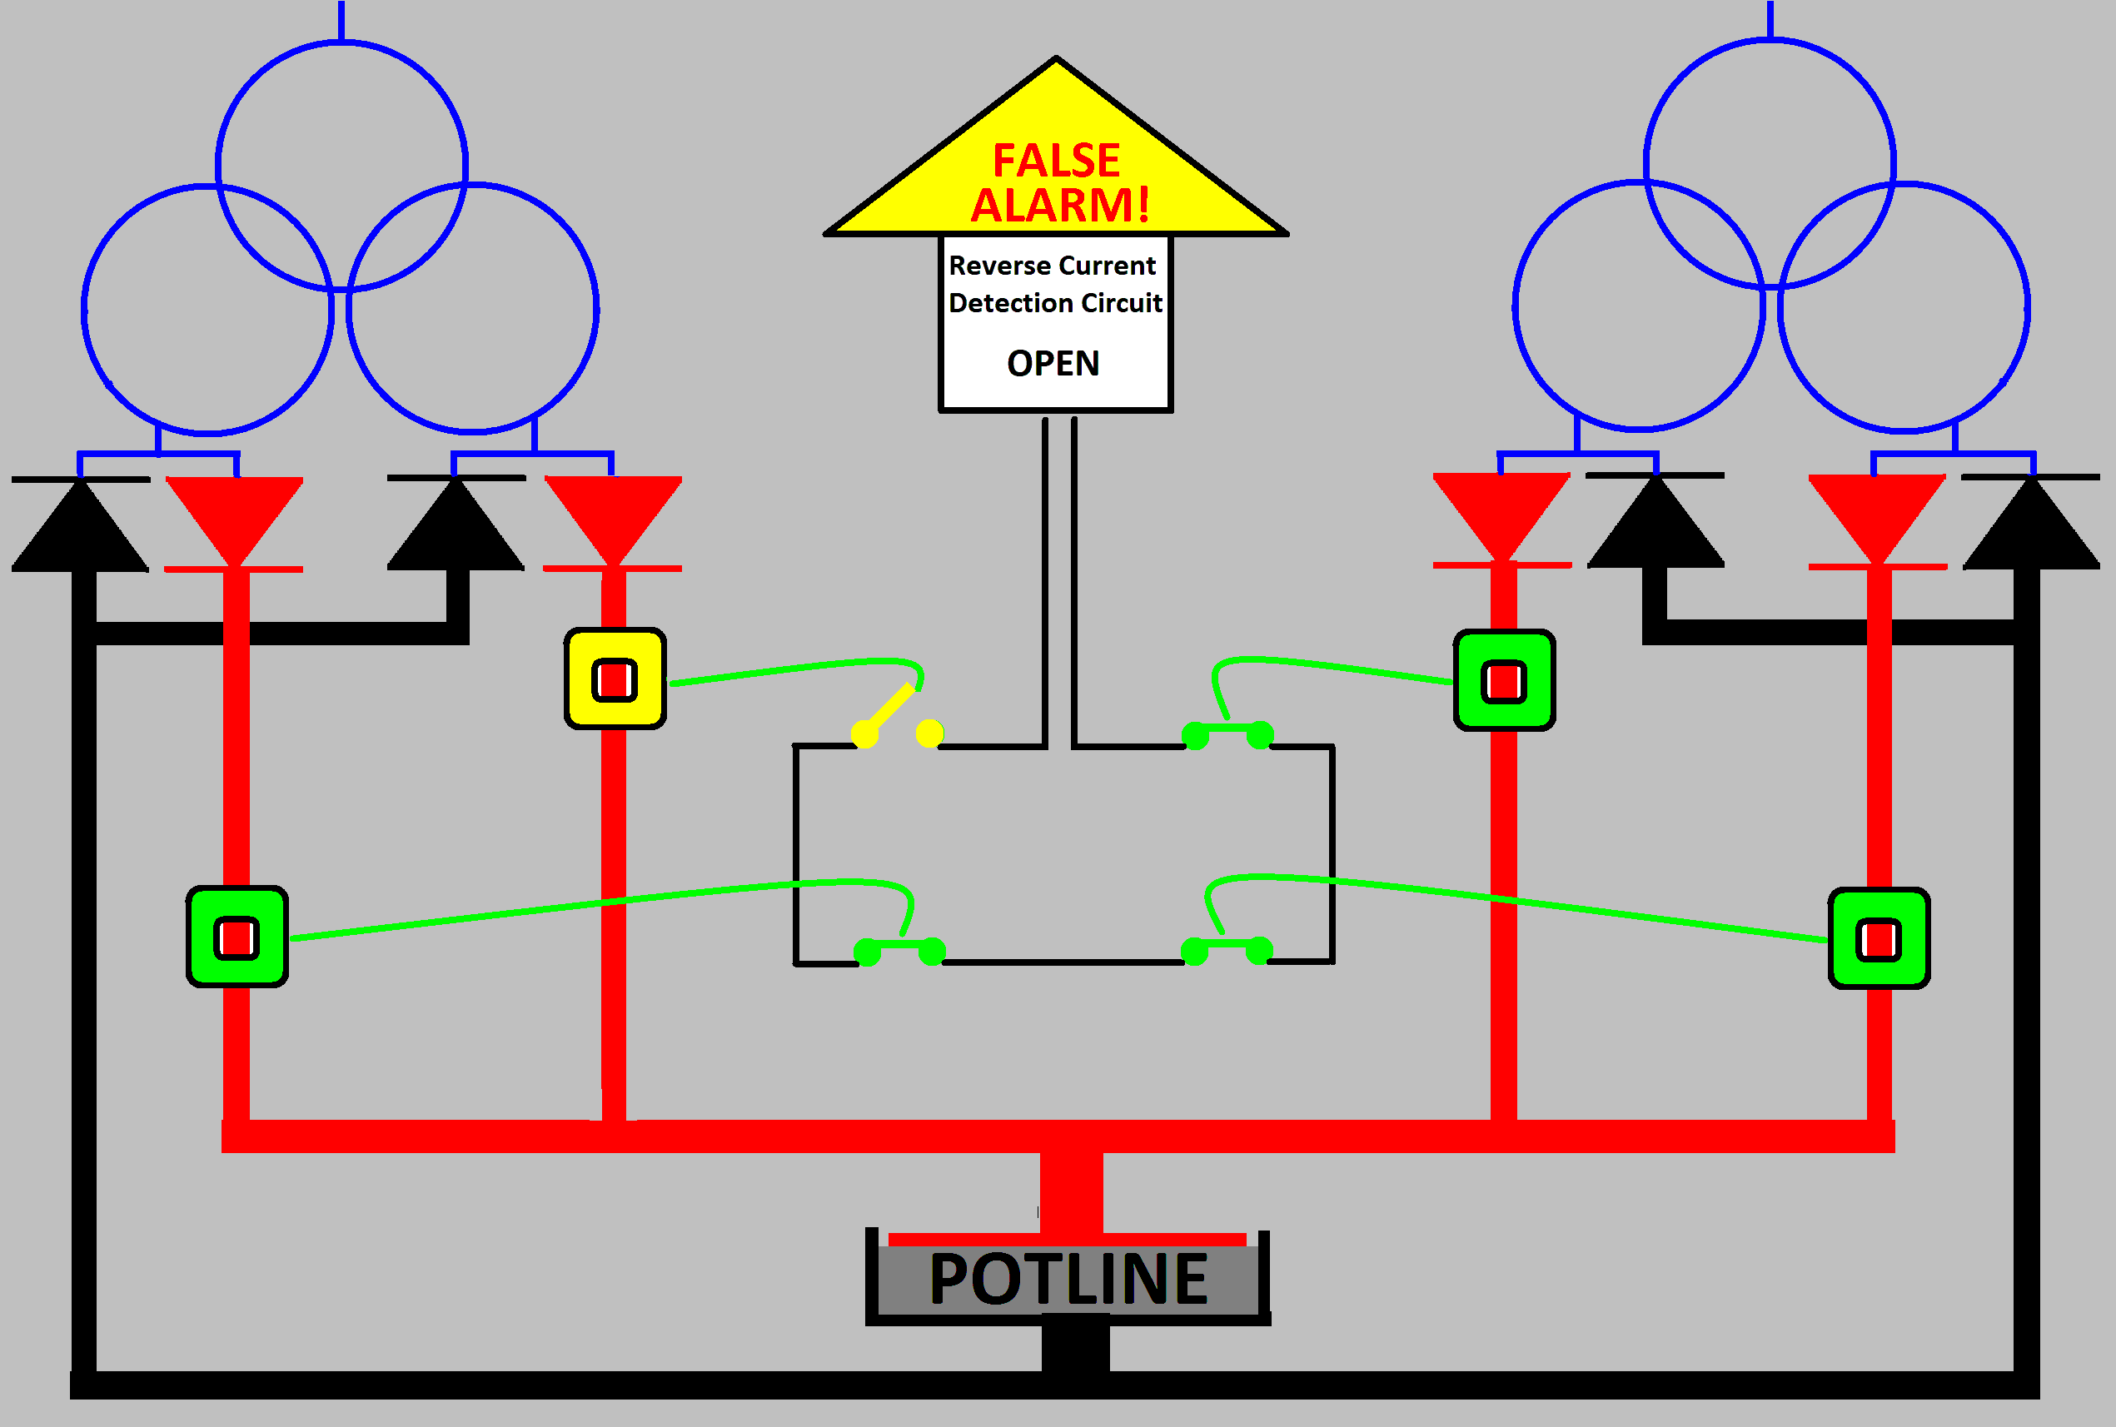

Extreme bus bar electrical noise, component failure, significant mains power noise or loss of power to an LKAT could cause a false trip depending on how it is configured. This is noted by the yellow LKAT in the diagram above. This false detection opens the overall circuit signaling a reverse current event which trips all rectifiers off line.

Such a false alarms can result in lost production and unnecessary ‘event’ investigations. In any case, the benefit of minimizing the damage and loss caused by a real reverse current event is always significantly greater than any nuisance costs from false alarms.

Depending on any single system for something as critical as reverse current detection is not ideal. This illustrates the need for a second, redundant RCDS. A redundant approach would provide two significant advantages.
- Reduce chances of false alarms
- Improve dependability of real reverse current detections
In the best case, the redundant RCDS should add a different product, not simply a second ‘same’ product that would have all the same chances of false alarm as the original. And finally, it must be able to be realized cost effectively.

Redundant RCDS Configurations

DynAmp’s BRP “Basic Rectifier Protection” product was specifically designed to be a simple, single-function RCDS. When added to an LKAT based RCDS, a truly redundant RCDS can be realized very cost effectively.

The diagram below shows the basic configuration of a Redundant RCDS. This involves installing BRP on the same bus bar as the LKAT so they are detecting the same current.

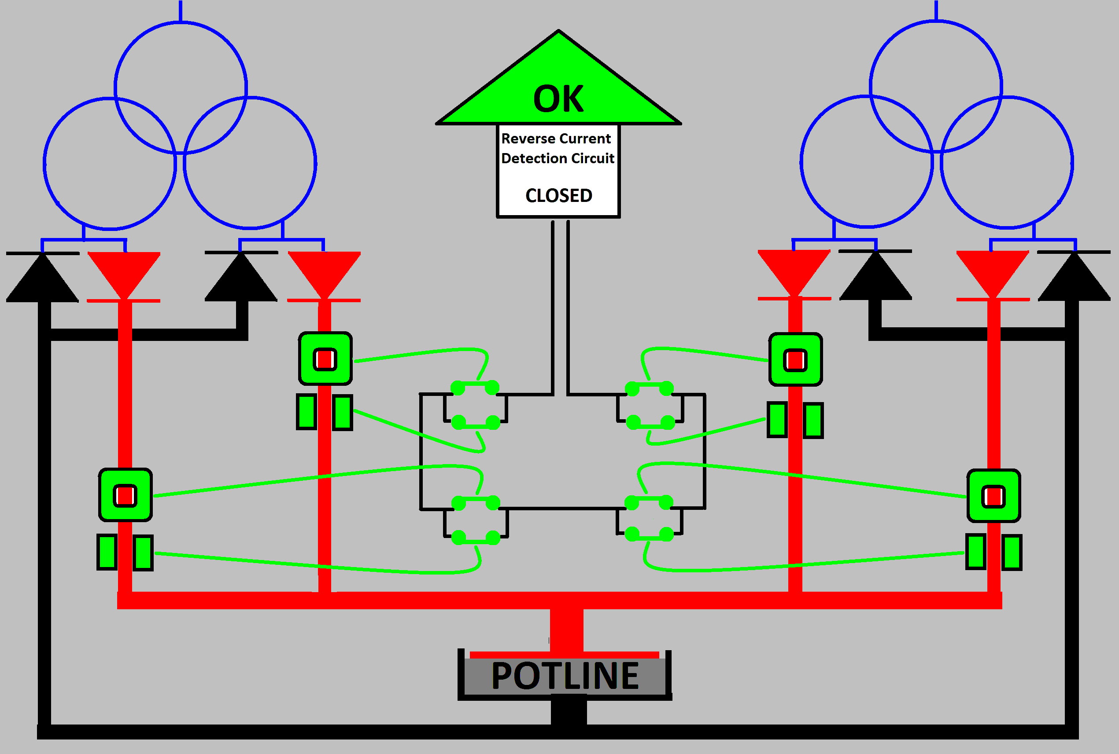

The LKAT () and BRP () do not interfere with or influence each other in any way so they can be installed immediately next to each other. Like the LKAT, the BRP controls its own relay / dry contact that is wired in ‘parallel’ with the original LKAT relay / dry contact.

Each rectifier’s parallel ‘redundant’ contact pair are still wired in series with those of the other rectifiers. The ‘Reverse Current Detection Circuit’ functions as before. It remains ‘closed’ during normal operating conditions.
The following diagram shows a short circuit in one of the rectifiers (as shown in yellow).

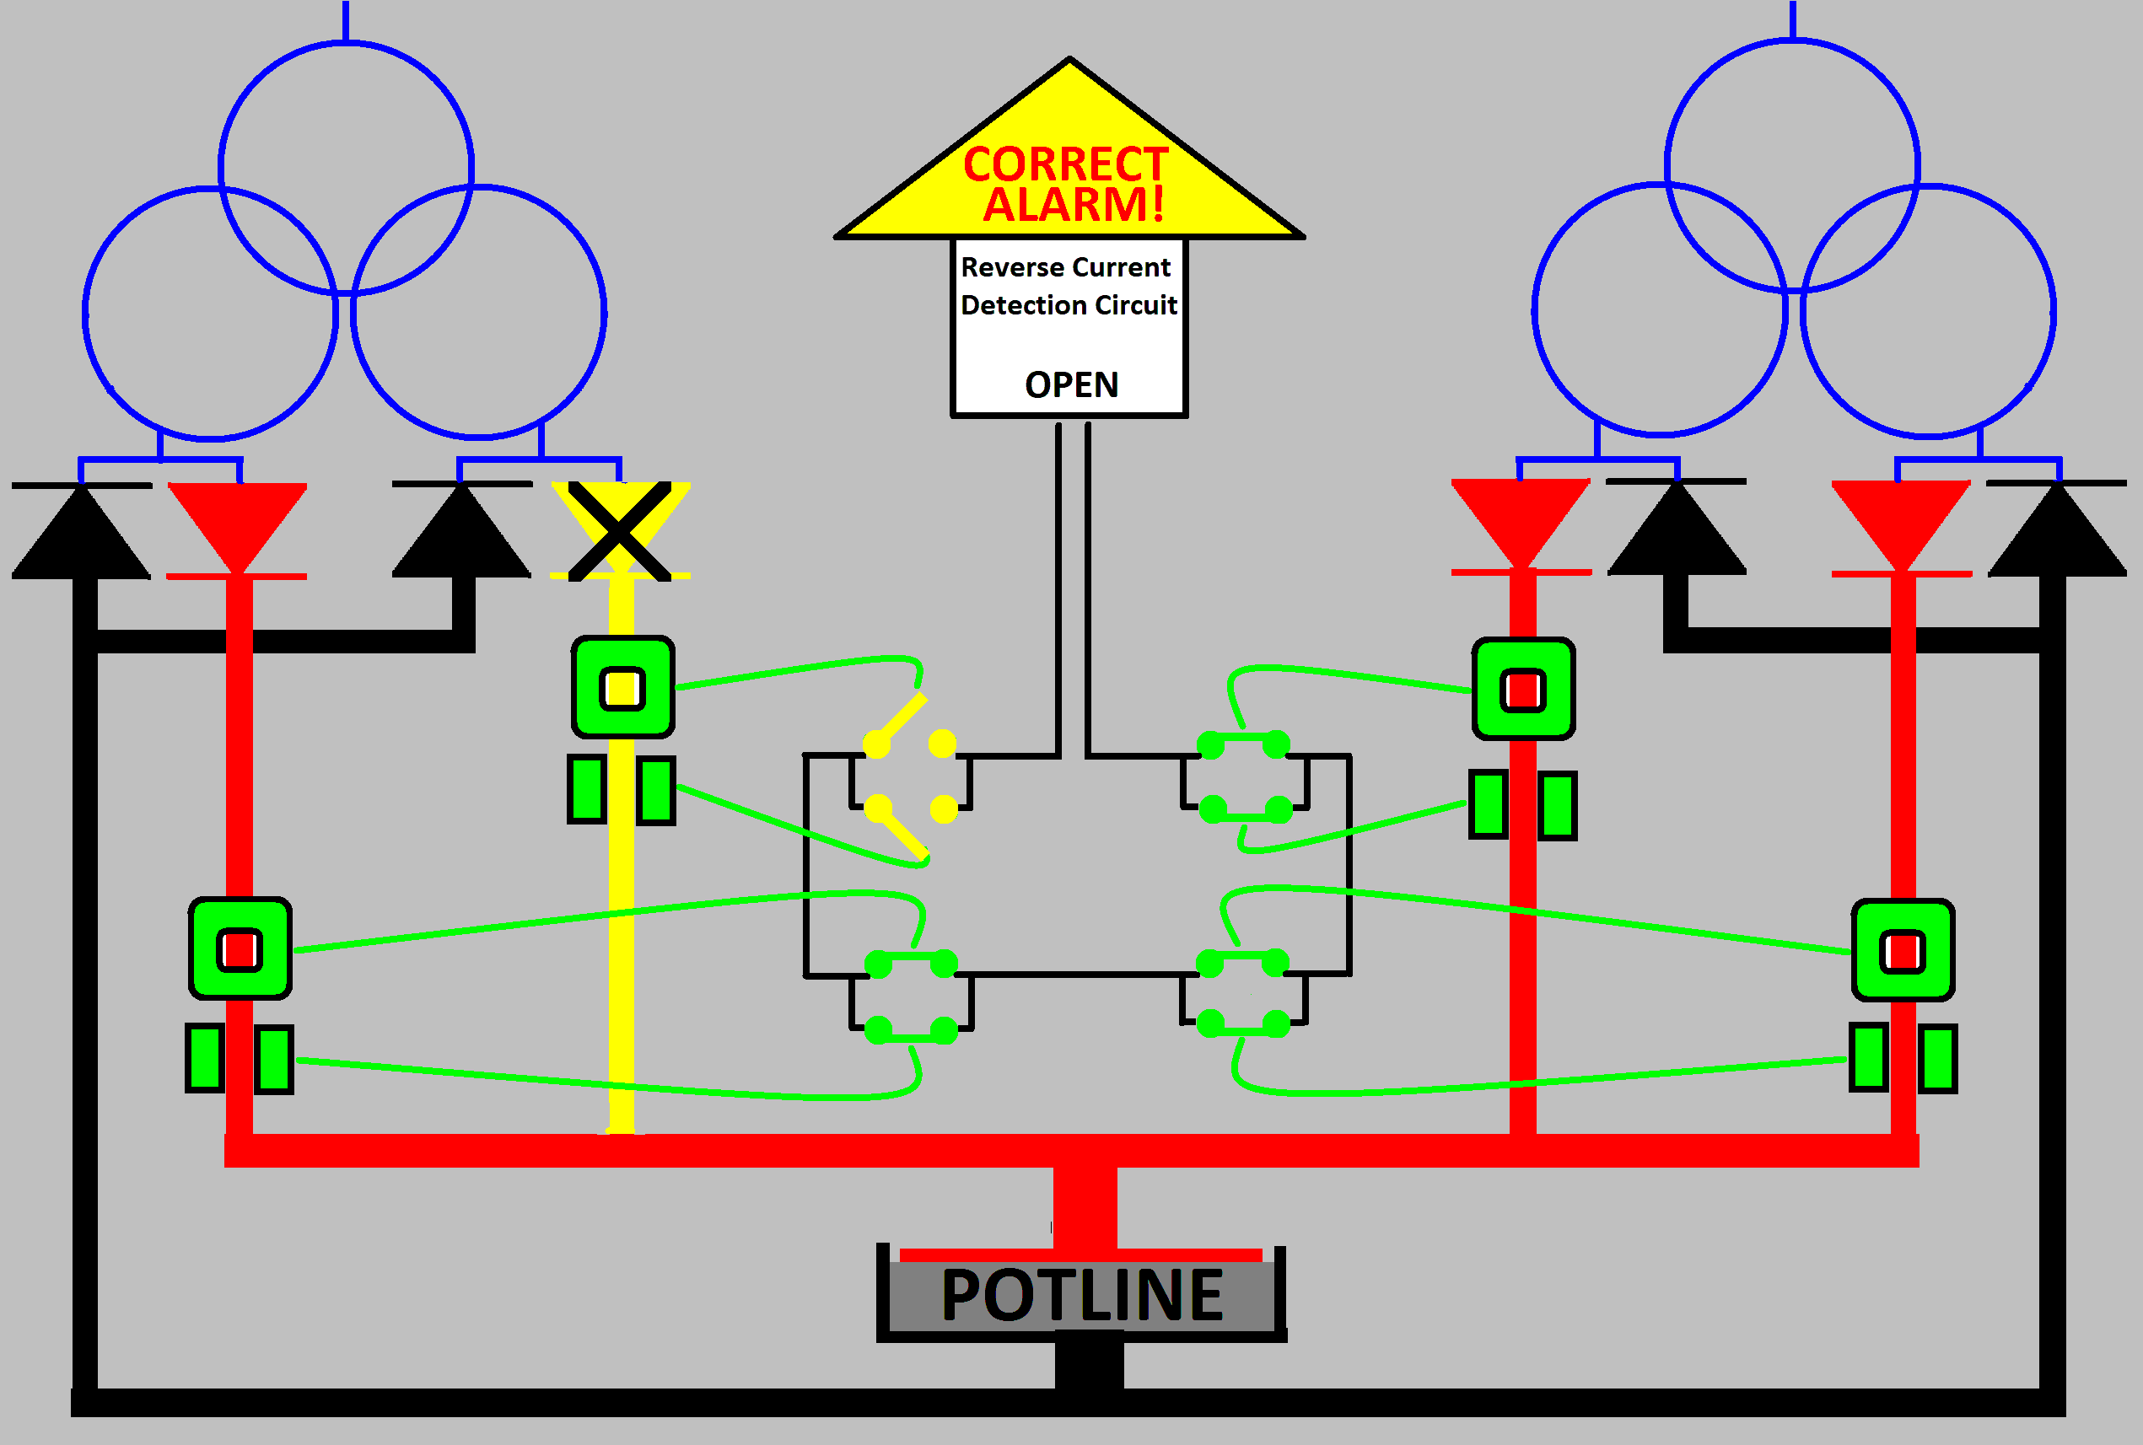

BOTH the LKAT and the BRP will detect the reverse current in the yellow bus bar (reverse current coming from the other parallel rectifiers). Each will ‘open’ its dry contact accordingly. With both contacts open, the overall Reverse Current Detection Circuit will ‘open’ to trip all rectifiers off line to minimize damage.
As noted previously, there could be conditions such as extreme bus bar electrical noise, component failure, significant mains power noise or loss of power that could cause LKAT or BRP to signal a false trip. This is noted by the yellow LKAT in the diagram below.

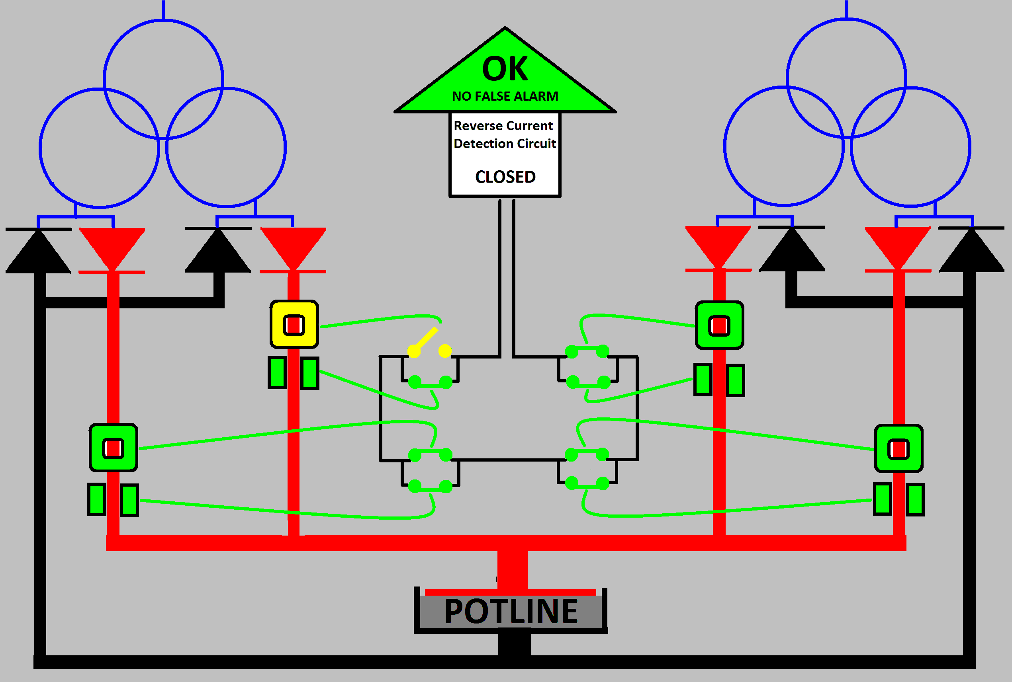

However, as illustrated above, a false alarm from one system ( LKAT in the example above ) will not cause a false alarm. The power rectifiers will not be tripped off line so the process can continue without interruption.

DynAmp Reverse Current Detection Products and Experience
DynAmp has been providing Reverse Current Detection Products for over 50 years. DynAmp’s BCMR and more recently LKAT and BRP products have been integrated into reverse and over current protection schemes wherever high power rectifiers are used.

DynAmp’s Redundant RCDS incorporates the following.

LKAT: Provides accurate rectifier output current measurement
Provides reverse current detection via dry contact output
Optional : a second, independently scaled and isolated measurement output
two additional, independently configured dry contact outputs
( typically used for over current protection )

BRP : Provides reverse current detection via status signal

Reverse Current Detection Circuit relays with latching and LED indication
If there is even a momentary reverse current alarm, the dry contact change of state of either system ( LKAT and BRP ) can be latched in the alarm position so it is clear which system ( or both systems ) detected a reverse current event. This is clearly displayed locally via an LED. A latched contact and LED are reset via a manual push button switch. A remote reset switch can also be connected.

Independent / different power supply accepted for each system
Both LKAT and BRP can be powered by different supplies including 100-240VAC, 100-240VDC or 24-32VDC. By using different power sources, redundancy is further enhanced.

Can be retrofitted to existing LKAT installations
For sites already equipped with LKAT systems, DynAmp can retrofit the additional components to upgrade protection to Redundant Reverse Current Protection.

